**Endovascular Coiling Versus Neurosurgical Clip-Reconstruction: Development of a State-Transition Model to Estimate Individualized Aneurysm Treatment Benefit**

Jordi de Winkel, MD1,2,*; Tim Y. Cras, MD1; Esmee Venema, MD, PhD2; Ruben Dammers, MD, PhD3; Pieter-Jan van Doormaal, MD4; Mathieu van der Jagt, MD, PhD5; Diederik W.J. Dippel,MD, PhD1; Bob Roozenbeek, MD, PhD1; Hester F. Lingsma,PhD2.

**List of supplemental material**

Supplemental Methods 1 – CHEERS Checklist

Supplemental Figure 1 – Baseline health state distribution stratified per treatment strategy.

Supplemental Figure 2 – Cumulative hazard function (stratified).

Supplemental Figure 3 – Tornado diagram.

Supplemental Figure 4 – Probabilistic sensitivity analysis.

Supplemental Figure 5 – ISAT microsimulation predicted QALE with endovascular coiling and neurosurgical clip-reconstruction (undiscounted).

Supplemental Table 1 – Event probability at longest follow-up.

Supplemental Table 2 – State-transition probabilities after rebleed.

Supplemental Table 3 – State-transition probabilities after retreatment.

Supplemental Table 4 – mRS and GOS conversion algorithm.

Supplemental Table 5 – Baseline characteristics of the benefit population.

**Supplemental Methods 1.** Consolidated Health Economic Evaluation Reporting Standards (CHEERS) Statement.

| **Topic** | **No.** | **Item** | **Location where item is reported** |
| --- | --- | --- | --- |
| **Title** |  |  |  |
| 1 | Identify the study as an economic evaluation and specify the interventions being compared. | 1 |
| **Abstract** |  |  |  |
| 2 | Provide a structured summary that highlights context, key methods, results, and alternative analyses. | 3-4 |
| **Introduction** |  |  |  |
| **Background and objectives** | 3 | Give the context for the study, the study question, and its practical relevance for decision making in policy or practice. | 5-6 |
| **Methods** |  |  |  |
| **Health economic analysis plan** | 4 | Indicate whether a health economic analysis plan was developed and where available. | NA |
| **Study population** | 5 | Describe characteristics of the study population (such as age range, demographics, socioeconomic, or clinical characteristics). | 6 |
| **Setting and location** | 6 | Provide relevant contextual information that may influence findings. | 5-6 |
| **Comparators** | 7 | Describe the interventions or strategies being compared and why chosen. | 6 |
| **Perspective** | 8 | State the perspective(s) adopted by the study and why chosen. | 5-6, disc. |
| **Time horizon** | 9 | State the time horizon for the study and why appropriate. | 5-6 |
| **Discount rate** | 10 | Report the discount rate(s) and reason chosen. | 7 |
| **Selection of outcomes** | 11 | Describe what outcomes were used as the measure(s) of benefit(s) and harm(s). | 6 |
| **Measurement of outcomes** | 12 | Describe how outcomes used to capture benefit(s) and harm(s) were measured. | 6 |
| **Valuation of outcomes** | 13 | Describe the population and methods used to measure and value outcomes. | 6 |
| **Measurement and valuation of resources and costs** | 14 | Describe how costs were valued. | NA |
| **Currency, price date, and conversion** | 15 | Report the dates of the estimated resource quantities and unit costs, plus the currency and year of conversion. | NA |
| **Rationale and description of model** | 16 | If modelling is used, describe in detail and why used. Report if the model is publicly available and where it can be accessed. | 7,16 |
| **Analytics and assumptions** | 17 | Describe any methods for analysing or statistically transforming data, any extrapolation methods, and approaches for validating any model used. | 7-8,13-15 |
| **Characterising heterogeneity** | 18 | Describe any methods used for estimating how the results of the study vary for subgroups. | NA |
| **Characterising distributional effects** | 19 | Describe how impacts are distributed across different individuals or adjustments made to reflect priority populations. | NA |
| **Characterising uncertainty** | 20 | Describe methods to characterise any sources of uncertainty in the analysis. | 14 |
| **Approach to engagement with patients and others affected by the study** | 21 | Describe any approaches to engage patients or service recipients, the general public, communities, or stakeholders (such as clinicians or payers) in the design of the study. | 15-16 |
| **Results** |  |  |  |
| **Study parameters** | 22 | Report all analytic inputs (such as values, ranges, references) including uncertainty or distributional assumptions. | 8-12 |
| **Summary of main results** | 23 | Report the mean values for the main categories of costs and outcomes of interest and summarise them in the most appropriate overall measure. | NA |
| **Effect of uncertainty** | 24 | Describe how uncertainty about analytic judgments, inputs, or projections affect findings. Report the effect of choice of discount rate and time horizon, if applicable. | 19 |
| **Effect of engagement with patients and others affected by the study** | 25 | Report on any difference patient/service recipient, general public, community, or stakeholder involvement made to the approach or findings of the study | NA |
| **Discussion** |  |  |  |
| **Study findings, limitations, generalisability, and current knowledge** | 26 | Report key findings, limitations, ethical or equity considerations not captured, and how these could affect patients, policy, or practice. | 21-24 |
| **Other relevant information** |  |  |  |
| **Source of funding** | 27 | Describe how the study was funded and any role of the funder in the identification, design, conduct, and reporting of the analysis | 25 |
| **Conflicts of interest** | 28 | Report authors conflicts of interest according to journal or International Committee of Medical Journal Editors requirements. | 25 |

*From:* Husereau D, Drummond M, Augustovski F, et al. Consolidated Health Economic Evaluation Reporting Standards 2022 (CHEERS 2022) Explanation and Elaboration: A Report of the ISPOR CHEERS II Good Practices Task Force. Value Health 2022;25. <doi:10.1016/j.jval.2021.10.008>

**Supplemental Figure 1.** Baseline health state distribution stratified per treatment strategy.

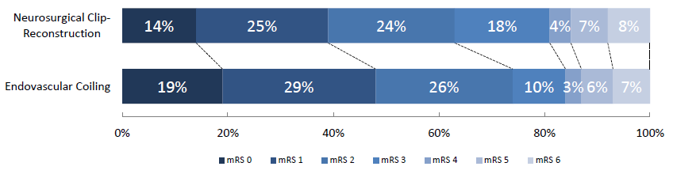

**Abbreviations:** mRS = modified Rankin Scale Score.

**Supplemental Figure 2.** Cumulative hazard function (stratified for endovascular coiling and neurosurgical clip-reconstruction).

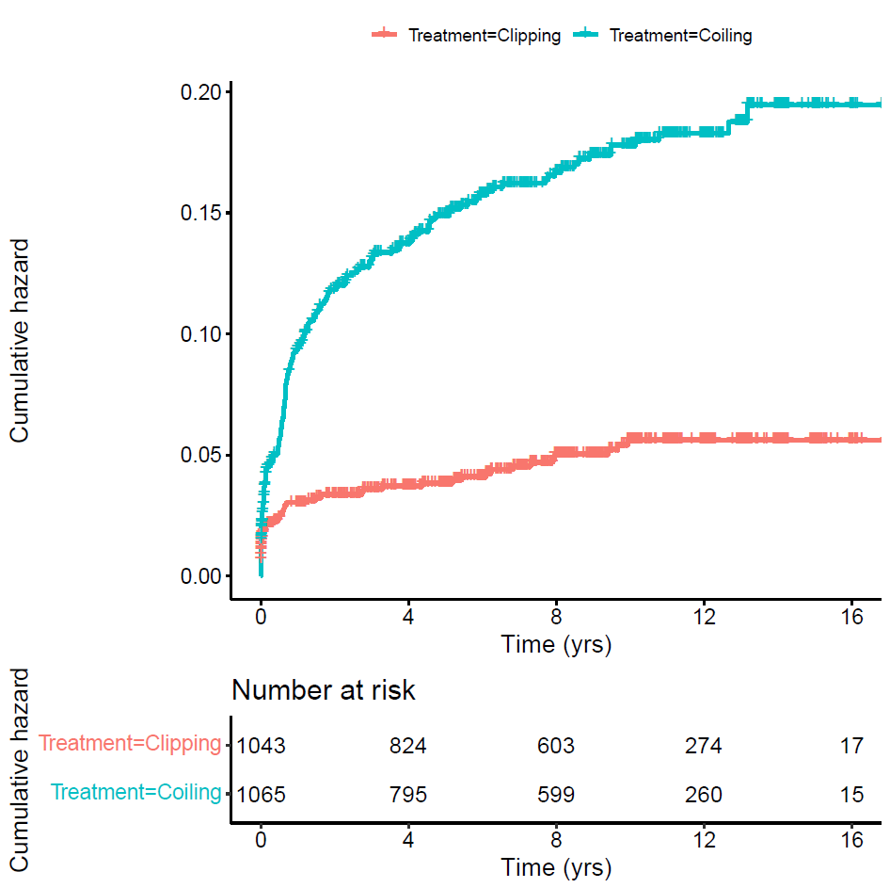

**Supplemental Figure 3.** Tornado-plot with the effect of changes in model parameters on the optimal treatment strategy.

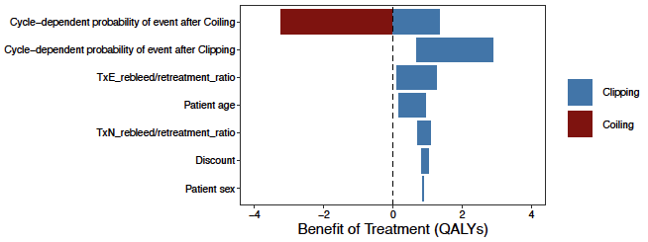

**Supplemental Figure 4.** Probabilistic sensitivity analysis.

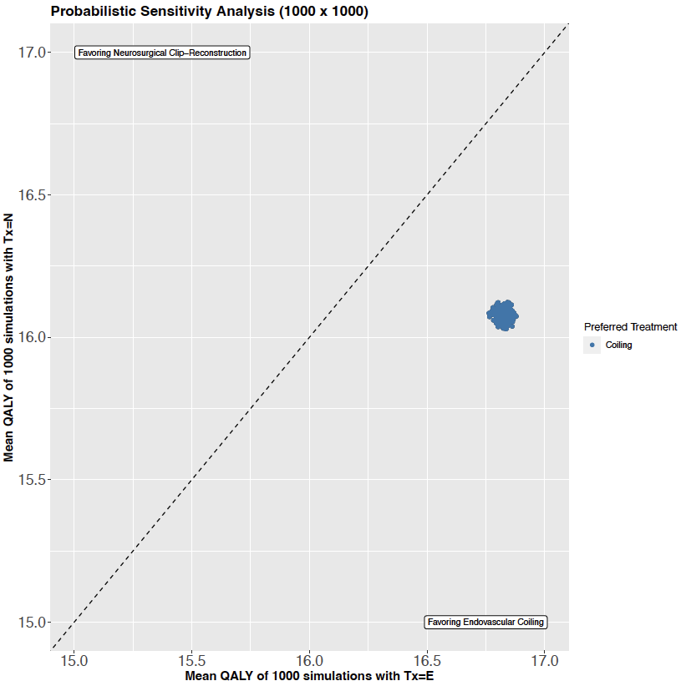

**Abbreviations:** QALE = quality-adjusted life expectancy.

**Supplemental Figure 5.** ISAT microsimulation predicted QALE with endovascular coiling and neurosurgical clip-reconstruction (undiscounted).

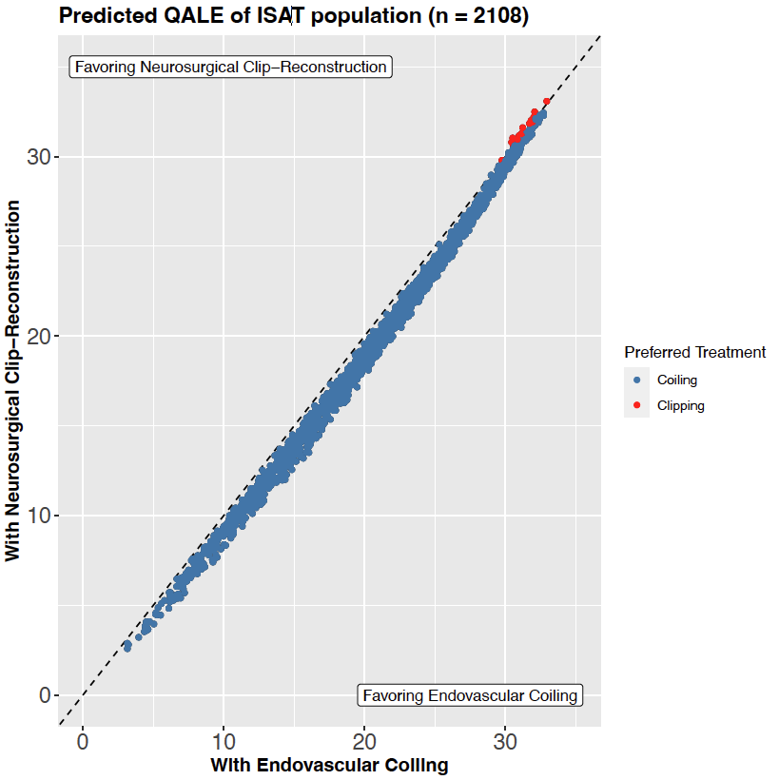

**Abbreviations:** ISAT = International Subarachnoid Aneurysm Trial, QALE = quality-adjusted life expectancy.

**Supplemental Table 1.** Rebleeding and Retreatment at longest follow-up stratified per treatment strategy.

|  |  |  |
| --- | --- | --- |
| **Outcome** | **Coiling (n = 1043)** | **Clip-reconstruction (n = 1070)** |
| No event | 1022 (0.955) | 883 (0.847) |
| Event | 160 (0.153) | 48 (0.045) |
| Rebleed | 50 (0.3125) | 24 (0.50) |
| Retreatment | 110 (0.6875) | 24 (0.50) |

**Supplemental Table 2.** State-transition probabilities after rebleed.

|  |  |  |  |  |  |  |  |  |
| --- | --- | --- | --- | --- | --- | --- | --- | --- |
|  | | Prerebleed mRS | | | | | | |
| mRS 0‡ | mRS 1 | mRS 2 | mRS 3 | mRS 4 | mRS 5 | mRS 6 |
| Post rebleed mRS | mRS 0 | 912 | *n/a* | *n/a* | *n/a* | *n/a* | *n/a* | *n/a* |
| mRS 1 | 911 | 911 | *n/a* | *n/a* | *n/a* | *n/a* | *n/a* |
| mRS 2 | 562 | 562 | 562 | *n/a* | *n/a* | *n/a* | *n/a* |
| mRS 3 | 266 | 266§ | 266§ | 266§ | *n/a* | *n/a* | *n/a* |
| mRS 4 | 265 | 265§ | 265§ | 265§ | 265 | *n/a* | *n/a* |
| mRS 5 | 48 | 48 | 48 | 48 | 48 | 48 | *n/a* |
| mRS 6 | 377 | 377 | 377 | 377 | 377 | 377 | 377 |
| N tot | 3341 | 2429 | 1518 | 956 | 690 | 425 | 377 |

**Abbreviations:** mRS = modified Rankin Scale score, n/a = not applicable.

The distributions of functional outcome are derived from Galea et al (2017, n = 3347). This study provides outcome data of SAH patients from a large consecutively included observational retrospective cohort at discharge. This means that the probabilities of state transitioning not related to having the event has been modelled separately. We used beta and Dirichlet distributions. We derived transition probabilities from a baseline mRS score to all the other categories by omitting the mRS 0 category. Because the GOS uses less categories than the mRS we divided GOS 5 and GOS 3 by 2 to obtain mRS 0 and 1 and mRS 2 and 3.

**Supplemental Table 3.** State transitioning after retreatment.

|  |  |  |  |  |  |  |  |  |
| --- | --- | --- | --- | --- | --- | --- | --- | --- |
|  | | Pretreatment mRS | | | | | | |
| mRS 0‡ | mRS 1 | mRS 2 | mRS 3 | mRS 4 | mRS 5 | mRS 6 |
| Post treatment mRS | mRS 0 | 14097 | n/a | n/a | n/a | n/a | n/a | n/a |
| mRS 1 | n/a | 14097 | n/a | n/a | n/a | n/a | n/a |
| mRS 2 | n/a | n/a | 14097 | n/a | n/a | n/a | n/a |
| mRS 3 | 159 | 159 | 159 | 14097 | n/a | n/a | n/a |
| mRS 4 | 159 | 159 | 159 | 238 | n/a | n/a | n/a |
| mRS 5 | 158 | 158 | 158 | 238 | n/a | n/a | n/a |
| mRS 6 | 216 | 216 | 216 | 216 | n/a | n/a | n/a |
| N tot | 14889 | 14889 | 14889 | 14889 | n/a | n/a | n/a |

**Abbreviations:** mRS = modified Rankin Scale score, n/a/ = not applicable.

Probabilities are derived from Naggara et al. (2012, n = 5044) and Kotowski et al. (2012, n = 9845).These studies investigated procedure-related poor outcomes with endovascular aneurysm treatment and neurosurgical aneurysm treatment of UIAs. Outcomes were assessed at 1 month in the study by Naggara et al. and at varying time points in the study of Kotowski et al. Both studies categorized functional outcome in favorable, unfavorable and death. Naggara et al defined favorable outcomes as mRS 0-2, unfavorable as mRS 3-5, and death as mRS 6. Kotowski et al. defined favorable outcome as mRS 0-2, GOS 4-5, or EGFP excellent or good, unfavorable outcome as mRS3-5, GOS 2-3, or EGFP fair-poor, and death as mRS 6 or GOS 1. Because we do not know if a patient receives endovascular or neurosurgical retreatment, we used pooled outcomes. We assumed that the risk of treatment-related complications was equal to elective retreatment of an aneurysm.

**Supplemental Table 4.** modified Rankin Scale and conversion from Glasgow Outcome Scale.

|  |  |  |
| --- | --- | --- |
| **Description** | **mRS** | **GOS** |
| No symptoms | 0 | 5 |
| No significant disability, despite symptoms; able to perform all usual activities | 1 | 5 |
| Slight disability; unable to perform all previous activities but able to look after own affairs without assistance | 2 | 4 |
| Moderate disability; requires some help, but able to walk without assistance | 3 | 3 |
| 4 Moderate-severe disability; unable to walk without assistance and unable to attend to own bodily needs without assistance | 4 | 3 |
| 5 Severe disability; bedridden, incontinent and requires nursing care and attention | 5 | 2 |
| 6 Death | 6 | 1 |

**Abbreviations:** GOS = Glasgow Outcome Scale, mRS = modified Rankin Scale.

**Supplemental Table 5.** Baseline characteristics of the derivation cohort and the population that may benefit from neurosurgical clip-reconstruction.

|  |  |  |
| --- | --- | --- |
| **Variable** | **Derivation cohort (*n* = 2143)** | **Population that may benefit from neurosurgical clip-reconstruction (*n* = 12)** |
| Age (years) – mean (SD) | 52 (11.6) | 25 (4.8) |
| WFNS grade – No. (%) |  |  |
| I | 1335 (62) | 13 (100) |
| II | 549 (26) | 0 |
| III | 134 (6) | 0 |
| IV | 74 (3) | 0 |
| V | 20 (1) | 0 |
| Fisher grade – No. (%) |  |  |
| 1 | 114 (5) | 1 (8) |
| 2 | 360 (17) | 8 (62) |
| 3 | 902 (42) | 4 (30) |
| 4 | 753 (35) | 0 |
| Severity of vasospasm at presentation – No. (%) |  |  |
| Absent | 1694 (79) | 11 (85) |
| Present | 449 (21) | 2 (15) |
| Aneurysm lumen size (mm) – median (IQR) | 5 (4-7) | 6 (5-6) |
| Aneurysm neck size >4mm – No. (%) | 580 (27) | 3 (23) |
| Aneurysm location – No. (%) |  |  |
| Anterior cerebral artery | 528 (25) | 0 |
| Anterior communicating artery | 556 (26) | 7 (54) |
| Internal carotid artery | 490 (23) | 3 (23) |
| Middle cerebral artery | 303 (14) | 2 (15) |
| Posterior communicating artery | 207 (10) | 1 (8) |
| Other posterior circulation aneurysms* | 59 (3) | 0 |
| Time-to-aneurysm-treatment (days) – median (IQR)† | 3 (2-6) | 3 (2-4) |

**Abbreviations:** CT = computed tomography, IQR = interquartile range, mm = millimeter, mRS = modified Rankin Scale, SD = standard deviation, WFNS = World Federation of Neurological Surgeons grade

* Locations of aneurysms of the posterior circulation include the basilar artery, vertebral artery, superior cerebellar artery, anterior inferior cerebellar artery, posterior inferior cerebellar artery, and internal auditory artery.

† Time-to-aneurysm-treatment is truncated at 14 days. In the ordinal model, missing time-to-aneurysm-treatment will be imputed with the mean. In the Cox model, any patient that has not received aneurysm treatment will be imputed with 14 days.